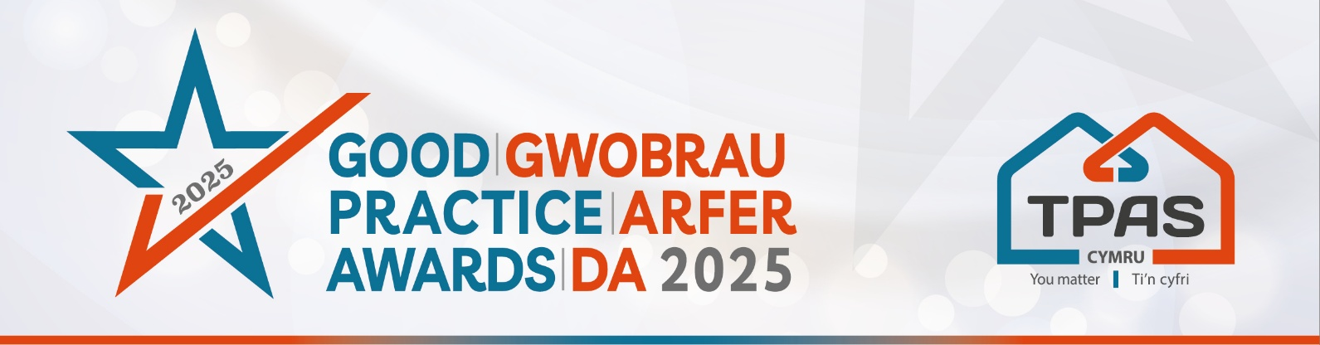

Assessment Criteria and Nomination Form for:

COMMUNICATING WITH TENANTS AND RESIDENTS

Category Details

This award recognises how effectively a social landlord communicates with its tenants and residents/service users. This could include a range of communication methods such as video, social media, newsletters, Facebook live and, direct ‘in person’ contact in communities etc.

It could also include a specific communication project to raise awareness or understanding of a particular topical issue, for example - fuel poverty, damp & mould, WHQS information.

Tell us about how you communicate with your tenants and what difference it is making, such as; raising awareness of services or the support you offer, building relationships and understanding; or being accountable about your organisation’s performance and plans. This award is inclusive of all methods of communication.

Assessment Criteria:

- The appropriateness of communication methods used in relation to diversity of the tenants e.g. plain language/avoiding jargon during communication.
- The effectiveness of the communication e.g. feedback from tenants/service users, social media analytics etc.
- The difference the communication has made

- Please ensure that your entry is submitted by completing this nomination form
- Make sure you reference the assessment criteria which the judges will use.
- Focus on the facts – we don’t need lengthy text, detailed bullet points are fine
- Feel free to include supporting information e.g. share links to publications, websites etc
- Please include at least one photo/image/screenshot.
- Please also see Guidance Booklet for tips and conditions of entry

Please complete the nomination form on the next page

Title of your Entry:
(this is what the nomination will be referred to in publications)
Contact Details of person submitting the nomination:

Name:

Telephone / Mobile number:

E-mail address:

An aim of the Awards is to share good practice with others. Will you be happy for us to share your contact details? Yes No

PROVIDE FULL DETAILS OF THE NOMINATION

Make sure you clearly cover all of the information in the assessment criteria for the category

Type here (there is an unlimited wordcount)

Please include at least one photo/image/screenshot – embed here or email separately

Please complete and return by noon 30th April 2025 to iona@tpas.cymru
No late entries will be considered

This event is kindly sponsored by:


