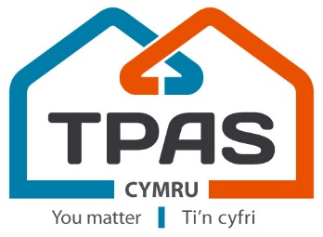
Creating Great Communities Conference
& Good Practice Awards Ceremony
Leonardo Hotel Cardiff - Wednesday 5th July 2023

Name:
Organisation / Tenant Group:
Email: | Telephone:
Please give details of any specific dietary needs?
Please give details of any accessibility needs? (e.g. wheelchair user, hearing loop or large print)
Anything else you think we need to be aware of?
Booking options | Tenants | Officers & Members of  TPAS Cymru | Non-Members of TPAS  Cymru
- Wednesday day conference only  This option includes refreshments on arrival and during the day and lunch | £84+vat  *£78 with  distance discount | £116+vat  *£105 with  distance discount | £219+vat  *£209 with  distance discount
- Evening Awards Ceremony & Gala Dinner only  This option includes light canapés and a glass of fizz on arrival, a 3-course meal followed by tea/coffee. | £73+vat | £84+vat | £159+vat
Saver package:  - Wednesday Day Conference + Evening Awards  The above 2 packages but with a saving of 4-10%) | £147+vat  *£137 with  distance discount | £179+vat  *£169 with  distance discount | £299+vat  *£289 with  distance discount

TERMS AND CONDITIONS
- All prices are exclusive of VAT
- Options do not include accommodation. If you wish to stay at this hotel you will need to book this direct with them on 0292 078 5590.
- The *distance discount applies to those bookings from organisations based 50 miles or more from the venue
- TPAS Cymru CANNOT accept any provisional bookings.
- Written confirmation is required for all cancellations. Cancellations received before the date of 23 June 2023 will be refunded, minus an administration fee of £30.00. No refunds will be processed after this date.
- Registered delegates who do not attend the event will be liable for payment in full unless written communication is received by the cancellation date.
- Any changes, such as names, made to the bookings after 23 June 2023 will incur an administration fee of £15.00 plus VAT per change.
- TPAS Cymru may have to cancel this event. In this case we will refund any payments received. We will not refund any costs you may incur as a result of the cancellation.

I have read and understood the above terms and conditions (please tick)

SIGNED: ..........................................................................................................................................................................................

PRINT NAME: ……………………………………………………………DATE: ……………………………………………………….

PAYMENT INFORMATION

I am sending a cheque made payable to TPAS Cymru for £__________ (remember to add VAT)

I am making a BACS payment to TPAS Cymru for £__________ (remember to add VAT)
Account Number: 07463731 Sort Code:56-00-41

Please invoice me for £______________

Name: | Job Title:
Organisation/Tenant Group:
Address:
Email:
PO Number:

Please return this form, signed and completed, before the deadline of
mid-day 23 June 2023 to: iona@tpas.cymru

